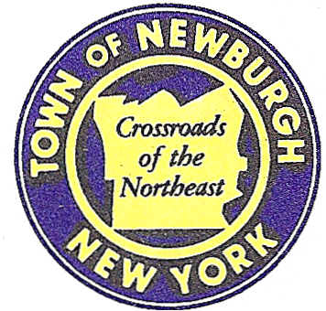

TOWN OF NEWBURGH
_______Crossroads of the Northeast __________________________
OLD TOWN HALL
308 GARDNERTOWN ROAD NEWBURGH, NEW YORK 12550

PLANNING BOARD
JOHN P. EWASUTYN, CHAIRMAN
TELEPHONE 845-564-7804
FAX 845-564-7802
E-MAIL: planningboard@townofnewburgh.org

PLANNING BOARD AGENDA

OCTOBER 15, 2015

*PLEASE NOTE: The Planning Board Meeting will start at 7:00 P.M. and all Applicants/Representatives
are to be present at that time. The Meeting will be held in the Meeting Room of Town Hall, located at
1496 Route 300, Newburgh NY.*

- Proposed Pet Hotel and Daycare (2012-19)  West side of Rt. 9W, north of Lattintown Road  Section 9, Block 3, Lot 22.2  Zone: B  Rep: T.M. DePuy Engineering & Land Surveying, P.C.  2656 Route 302  Middletown, New York 10941 | CONCEPTUAL  SITE PLAN
- Seriota Site Plan (2015-18)  NYS Route 17K  Section 94, Block 1, Lot 61  Zone: IB  Rep: Engineering & Surveying Properties  71 Clinton Street  Montgomery, NY 12549 | INITIAL APPEARANCE  SITE PLAN
*WORK SESSION*
Project Readiness Discussion scheduled for 5:30 p.m. in the Meeting Room of
Town Hall on Thursday, October 15, 2015.*

PLANNING BOARD BUSINESS
WORK SESSION

October 15, 2015
5:30 P.M.

Discussion:

1.

